**No Spread Factor Applied [0,0,0,0,0]**

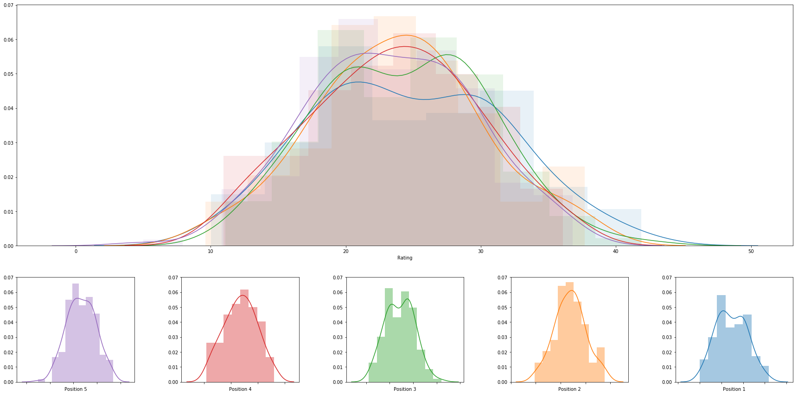

|  |  |  |  |  |  |  |  |
| --- | --- | --- | --- | --- | --- | --- | --- |
|  | **rank** | **name** | **college** | **division** | **rating** | **primary position** | **date** |
| **0** | 1 | Haley Hallgren | USC | DI | 41.92405332341287 | 3 | 2018-05-05 |
| **1** | 2 | Tina Graudina | USC | DI | 41.87750530496945 | 1 | 2018-05-05 |
| **2** | 3 | Victoria Paranagua | Florida State | DI | 39.75715637520556 | 1 | 2018-05-05 |
| **3** | 4 | Megan McNamara | UCLA | DI | 38.5789695981543 | 1 | 2018-05-06 |
| **4** | 5 | Nicole McNamara | UCLA | DI | 38.57896959815427 | 1 | 2018-05-06 |
| **5** | 6 | Taylor Nelson | Cal Poly SLO | DI | 38.276501357390075 | 3 | 2018-04-28 |
| **6** | 7 | Abril Bustamante | USC | DI | 38.11661762075409 | 1 | 2018-05-05 |
| **7** | 8 | Zana Muno | UCLA | DI | 37.77417492411943 | 3 | 2018-05-06 |
| **8** | 9 | Katie Horton | Florida State | DI | 37.68046429257491 | 2 | 2018-05-05 |
| **9** | 10 | Hailey Luke | Florida State | DI | 37.67239494074606 | 2 | 2018-05-05 |
| **10** | 11 | Sarah Sponcil | UCLA | DI | 37.07554867132963 | 2 | 2018-05-06 |
| **11** | 12 | Lily Justine | UCLA | DI | 37.07554867132963 | 2 | 2018-05-06 |
| **12** | 13 | Eva Torruella | Florida State | DI | 36.81266015311576 | 5 | 2018-04-22 |
| **13** | 14 | Sammy Slater | USC | DI | 36.22375355538331 | 2 | 2018-05-05 |
| **14** | 15 | Skylar Caputo | Pepperdine | DI | 36.076833998853395 | 4 | 2018-05-05 |
| **15** | 16 | Alexis Filippone | Pepperdine | DI | 36.076833998853395 | 4 | 2018-05-05 |
| **16** | 17 | Carly Kan | Hawaii | DI | 36.05141363929921 | 3 | 2018-05-06 |
| **17** | 18 | Amy Ozee | Hawaii | DI | 35.87428871623438 | 4 | 2018-05-06 |
| **18** | 19 | Ari Homayun | Hawaii | DI | 35.87428871623438 | 4 | 2018-05-06 |
| **19** | 20 | Laurel Weaver | Hawaii | DI | 35.75367878857133 | 3 | 2018-05-06 |
| **20** | 21 | Izzy Carey | UCLA | DI | 35.71886889991033 | 5 | 2018-05-06 |
| **21** | 22 | Megan Muret | UCLA | DI | 35.71886889991033 | 5 | 2018-05-06 |
| **22** | 23 | Molly McBain | Florida State | DI | 35.71678581246075 | 4 | 2018-05-05 |
| **23** | 24 | Francesca Goncalves | Florida State | DI | 35.61435449562621 | 5 | 2018-05-05 |
| **24** | 25 | Sunny Villapando | Stanford | DI | 35.58663627681979 | 1 | 2018-04-27 |
| **25** | 26 | Brooke Sassin | TCU | DI | 35.54790859380205 | 5 | 2018-04-15 |
| **26** | 27 | Sasha Karelov | Long Beach State | DI | 35.53041975876284 | 1 | 2018-04-28 |
| **27** | 28 | Madalyn Roh | Pepperdine | DI | 35.226635425688286 | 1 | 2018-05-05 |
| **28** | 29 | Brook Bauer | Pepperdine | DI | 35.226635425688286 | 1 | 2018-05-05 |
| **29** | 30 | Deahna Kraft | Pepperdine | DI | 35.19814647857444 | 2 | 2018-05-05 |
| **30** | 31 | Corinne Quiggle | Pepperdine | DI | 35.19814647857444 | 2 | 2018-05-05 |
| **31** | 32 | Ka'iwi Schucht | Hawaii | DI | 35.08617223568436 | 1 | 2018-05-06 |
| **32** | 33 | Emily Maglio | Hawaii | DI | 35.08617223568436 | 1 | 2018-05-06 |
| **33** | 34 | Elise Zappia | UCLA | DI | 34.92004967553376 | 4 | 2018-05-06 |
| **34** | 35 | Morgan Martin | Hawaii | DI | 34.89166415567322 | 2 | 2018-05-06 |
| **35** | 36 | Lea Monkhouse | Hawaii | DI | 34.70923360078793 | 2 | 2018-05-06 |
| **36** | 37 | Kristen Nuss | LSU | DI | 34.45521797470953 | 1 | 2018-05-04 |
| **37** | 38 | Claire Coppola | LSU | DI | 34.45521797470953 | 1 | 2018-05-04 |
| **38** | 39 | Jonny Baham | Arizona | DI | 34.39210180763454 | 4 | 2018-04-27 |
| **39** | 40 | Maddie Micheletti | Cal | DI | 34.2057260238942 | 5 | 2018-04-28 |
| **40** | 41 | Macy Jerger | Florida State | DI | 34.08166902189905 | 3 | 2018-05-05 |
| **41** | 42 | Hannah Zalopany | Hawaii | DI | 34.04503334824465 | 5 | 2018-05-06 |
| **42** | 43 | Sara Putt | Florida State | DI | 33.74503685450356 | 3 | 2018-05-05 |
| **43** | 44 | Gigi Hernandez | Pepperdine | DI | 33.71066157798925 | 3 | 2018-05-05 |
| **44** | 45 | Heidi Dyer | Pepperdine | DI | 33.71066157798925 | 3 | 2018-05-05 |
| **45** | 46 | Ashley Allmer | LSU | DI | 33.566446228214964 | 2 | 2018-04-08 |
| **46** | 47 | Mariana De Paula Silva | FIU | DI | 33.364668055901845 | 5 | 2018-04-13 |
| **47** | 48 | Grace Campbell | Cal | DI | 33.30002401098804 | 5 | 2018-04-28 |
| **48** | 49 | Nikki Lyons | Pepperdine | DI | 33.21010451337358 | 5 | 2018-05-05 |
| **49** | 50 | Hi'ilawe Huddleston | Hawaii | DI | 33.16474393384093 | 5 | 2018-04-15 |
| **50** | 51 | Paige Dreeuws | Hawaii | DI | 33.13096427219291 | 5 | 2018-05-06 |
| **51** | 52 | Sam Manley | Cal Poly SLO | DI | 33.00711167602936 | 2 | 2018-04-28 |
| **52** | 53 | Kaylie Mchugh | Tulane | DI | 33.004996948497094 | 1 | 2018-04-21 |
| **53** | 54 | Madeline Mertz | Tulane | DI | 33.004996948497094 | 1 | 2018-04-21 |
| **54** | 55 | Maddie Ligon | LSU | DI | 32.96737415389329 | 5 | 2018-05-04 |
| **55** | 56 | Jenna Belton | USC | DI | 32.89815684247553 | 4 | 2018-05-05 |
| **56** | 57 | Lilly Kessler | LSU | DI | 32.88552250291112 | 5 | 2018-04-15 |
| **57** | 58 | Courtney Bowen | Stanford | DI | 32.81558583834624 | 3 | 2018-04-27 |
| **58** | 59 | Carly Dehoog | Washington | DI | 32.59092171432187 | 3 | 2018-04-28 |
| **59** | 60 | Shayne Mcpherson | Washington | DI | 32.59092171432187 | 3 | 2018-04-28 |
| **60** | 61 | Savvy Simo | UCLA | DI | 32.526131645456154 | 3 | 2018-05-06 |
| **61** | 62 | Katie Smith | South Carolina | DI | 32.50752884562555 | 2 | 2018-05-04 |
| **62** | 63 | Emily Sonny | Cal Poly SLO | DI | 32.39716220383301 | 2 | 2018-04-28 |
| **63** | 64 | Taija Thomas | FIU | DI | 32.34003959373301 | 5 | 2018-05-04 |
| **64** | 65 | Hailey Harward | Long Beach State | DI | 32.3230559446965 | 3 | 2018-04-28 |
| **65** | 66 | Raeann Greisen | Cal Poly SLO | DI | 32.10768255713221 | 4 | 2018-04-28 |
| **66** | 67 | Macie Tendrich | South Carolina | DI | 32.09922001150813 | 4 | 2018-05-04 |
| **67** | 68 | Leah Perri | South Carolina | DI | 32.09922001150813 | 4 | 2018-05-04 |
| **68** | 69 | Mac May | UCLA | DI | 32.07433691512241 | 4 | 2018-05-06 |
| **69** | 70 | Marisa Ramsey | Long Beach State | DI | 32.04856077574099 | 5 | 2018-04-28 |
| **70** | 71 | Hannah Matt | Long Beach State | DI | 32.04856077574099 | 5 | 2018-04-28 |
| **71** | 72 | Nele Barber | Long Beach State | DI | 32.03980869057516 | 1 | 2018-04-28 |
| **72** | 73 | Lauren Durham | Stetson | DI | 32.01261901146752 | 4 | 2018-04-21 |
| **73** | 74 | Madi Yeomans | UCLA | DI | 31.969540435488742 | 3 | 2018-04-28 |
| **74** | 75 | Jessica Wooten | Houston Baptist | DI | 31.963549632193867 | 1 | 2018-04-22 |
| **75** | 76 | Aeriel Horton | Houston Baptist | DI | 31.963549632193835 | 1 | 2018-04-22 |
| **76** | 77 | Addison Hermstad | Tulane | DI | 31.90554896515713 | 4 | 2018-04-21 |
| **77** | 78 | Rachel Nieto | Long Beach State | DI | 31.620585242905687 | 2 | 2018-04-28 |
| **78** | 79 | Megan Kruidhof | Long Beach State | DI | 31.54653693916853 | 2 | 2018-04-28 |
| **79** | 80 | Nicci Reinking | Long Beach State | DI | 31.546020537347346 | 4 | 2018-04-28 |
| **80** | 81 | Kate Formico | Stanford | DI | 31.45186414004583 | 3 | 2018-04-27 |
| **81** | 82 | Alaina Chacon | Florida State | DI | 31.33006087881786 | 4 | 2018-04-15 |
| **82** | 83 | Olivia Stasevich | Georgia State | DI | 31.265481943072828 | 3 | 2018-04-21 |
| **83** | 84 | Terese Cannon | USC | DI | 31.231297035243745 | 2 | 2018-05-05 |
| **84** | 85 | Kristyna Adamcikova | Long Beach State | DI | 31.183694332870083 | 3 | 2018-04-27 |
| **85** | 86 | Federica Frasca | FIU | DI | 31.094137642049592 | 1 | 2018-05-04 |
| **86** | 87 | Margherita Bianchin | FIU | DI | 31.094137642049592 | 1 | 2018-05-04 |
| **87** | 88 | Julia Lewkowicz | FAU | DI | 31.002094186445177 | 5 | 2018-04-21 |
| **88** | 89 | Katrina Kernochan | USC | DI | 30.888359206867026 | 5 | 2018-04-10 |
| **89** | 90 | Megan Davenport | LSU | DI | 30.84232561185947 | 4 | 2018-05-04 |
| **90** | 91 | Zoi Konstantopoulou | Long Beach State | DI | 30.79489481909787 | 4 | 2018-04-28 |
| **91** | 92 | Darby Dunn | Stetson | DI | 30.772825572576124 | 1 | 2018-04-21 |
| **92** | 93 | Sammee Thomas | Stetson | DI | 30.772825572576114 | 1 | 2018-04-21 |
| **93** | 94 | Candice Denny | Arizona | DI | 30.728598664032194 | 3 | 2018-02-25 |
| **94** | 95 | Amanda Silva | FAU | DI | 30.689102503487998 | 1 | 2018-04-21 |
| **95** | 96 | Brooke Weiner | Georgia State | DI | 30.6888499933177 | 2 | 2018-04-21 |
| **96** | 97 | Kathryn Plummer | Stanford | DI | 30.641445727610755 | 1 | 2018-03-27 |
| **97** | 98 | Katrin Gotterba | Pacific | DI | 30.48061678800176 | 3 | 2018-04-21 |
| **98** | 99 | Alex Holt | Pacific | DI | 30.48061678800176 | 3 | 2018-04-21 |
| **99** | 100 | Tatum Ballard | LSU | DI | 30.464264695925785 | 4 | 2018-03-31 |